“COME AND JOIN ONE OF THE MOST ELECTRIFYING LEAGUES IN NEW YORK CITY”
“ONE OF THE MOST EXCITING GAMES OF THE EXCITING YEAR AGAIN”
“31ST ANNIVERSARY
“ 2 0 2 4 “

”

**** ALL STAR GAME *****

SUNDAYY COED ALL STARS GAME vs YTS COED ALL STARS

SUNDA MODIFIED LEAGUE ALLSTARS GAME

STRONGEST ARM, FASTEST MAN & HOME RUN DERBY CONTEST
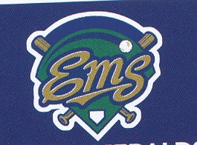

2024 NYC EMS LEAGUE ALL STAR GAME
Date : SUNDAY JUNE 16TH, 2024
Time : 9:45Am -4:00pm
PLACE: PELHAM BAY P[ARK, FIELD #2

CONTACT: COMMISSIONER C.J. JOHNSON AT (646) 489-7156
E EMAIL: CJCOMMISH@AOL.COM
WWW.NYCEMSSOFTBALLLEAGUE.COM

